Jialiang Cui

28) Wayne Enterprises stock is trading at $200. The option contract trading with the most volume, that expires in 30 days, is trading at $1.50. The implied volatility of that option contract is 25%. Graph the normal distribution of the implied prices. Make the graph red and make a blue shaded region for the probability of the implied price being greater then $275.

--

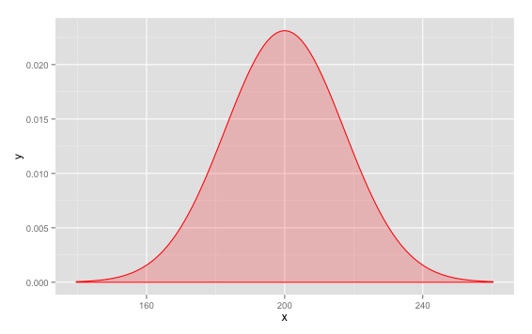

S = 200

std= 0.25*sqrt(30/252)*S

shade_limit <- function(x) {

y <- dnorm(x,200,std)

y[x<275]<-NA

return(y)

}

ggplot(data.frame(x = c(min(-3.5*std+S,-3.5*std+S), max(3.5*std+S,3.5*std+S))), aes(x=x)) +

stat_function(fun = dnorm, args = list(mean = S, sd = std), color="red",

geom="area", fill="red", alpha=0.2) +

stat_function(fun = shade_limit, geom="area", fill = "blue", alpha=0.3)

1 - pnorm(275,S,std)

The probability of greater than $275 is 6.887633e-06.

29) There are two businesses you are considering investing in, a pastry shop and a chocolate shop. The pastry shop earned $500 in revenue before paying taxes and Interest payments where as the chocolate shop made $750 in revenue before paying taxes and Interest. The pastry shop building is valued at $1000 and the chocolate shop building is valued at $1100. The pastry shop has $150 of receivables and the chocolate shop has $50 of receivables. What is the ROC for the pastry shop and chocolate shop?

EBIT-p = 500

EBIR-c = 750

NetP-p = 1000

NetP-c = 1100

NetWC-p = 150

NetWC-c = 50

ROC-p = EBIT-p/(NetP-p + NewWC-p) = 0.4348

ROC-c = 0.6522

30) From Question #29, the pastry shop has debt of $100 and the chocolate shop has debt of $450. The pastry shop has $300 in the checking account and the chocolate shop has $25 in the checking account. The chocolate shop has a junior partner with $100 ownership. What are the earnings yield? Which company would you buy?

Debt-p = 100

Debt-c = 450

Checking-p=300

Checking-c=25

Partner-c = 100

EY= EBIT/(MarketCap + TotalDebt - ExcessCash + PreferredStock + Minority)

EY-p = 500/(100 - 300 – 150) =

EY-c = 750/(450 – 25 – 50 + 100) =